Objective:
Use Subqueries, CTEs, and Window Functions to analyze sales data from the Superstore dataset.

Tasks

Step 1: Setup Data
- Import the Superstore dataset into a table named superstore_raw.
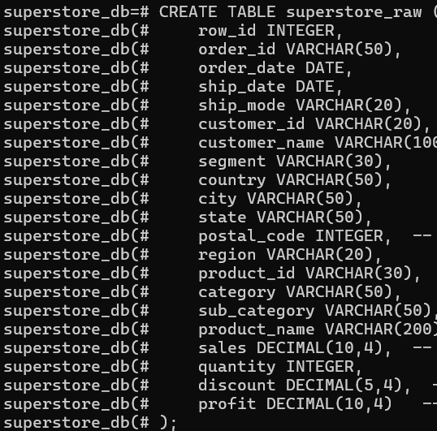
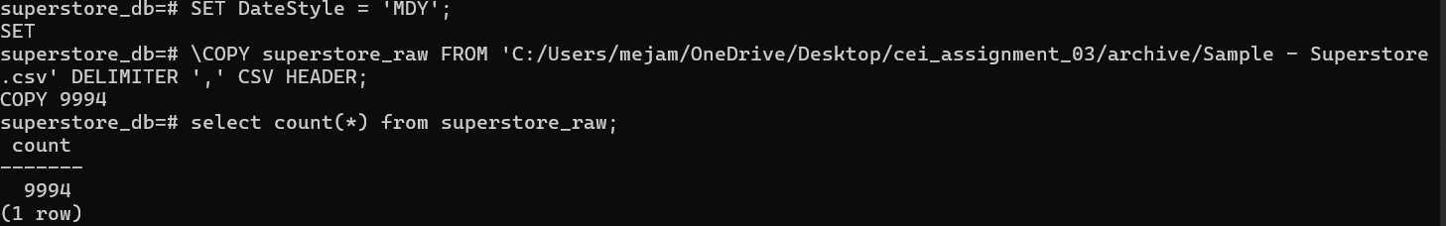

- Create these 3 tables from it:
  - customers

  - orders
  - products

- Insert data into these tables using SELECT DISTINCT.
QUERIES AND RESULTS:
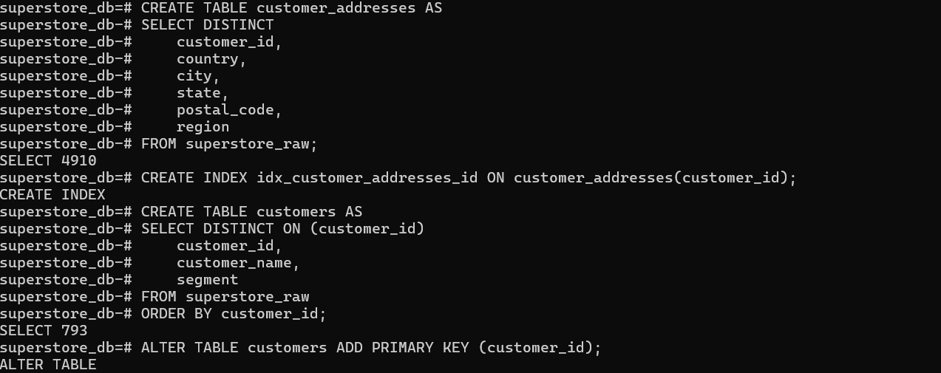
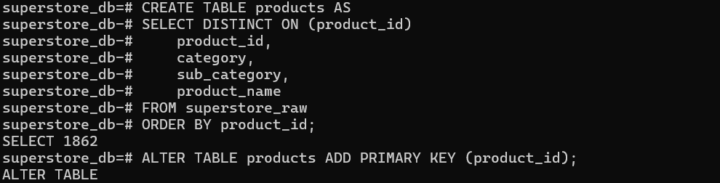
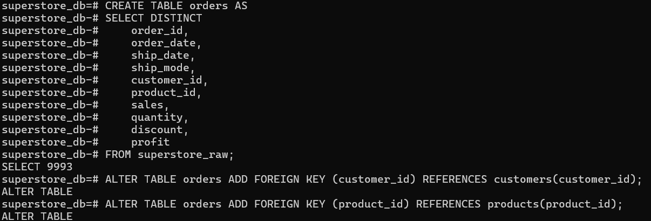
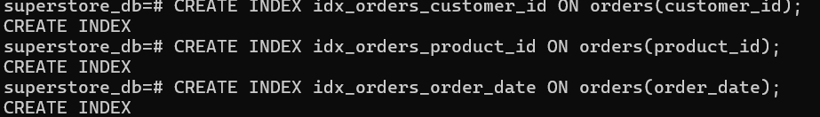
KEY INSIGHTS FROM STEP 1:
WHAT WE ACCOMPLISHED:
- Created database and imported raw CSV data
- Normalized data into 3 main tables (customers, products, orders)
- Created an additional address table for data preservation
- Handled duplicates and data quality issues

ISSUES FACED and SOLUTIONS:

- CSV had MM/DD/YYYY, PostgreSQL expected YYYY-MM-DD
Sol: We used SET DATESTYLE:’MDY’

- COPY couldn't read local file
Sol: Used \COPY (client-side) instead of COPY (server-side)

- One duplicate order existed(US-2014-150119 appeared twice with identical values)
Sol: Used SELECT DISTINCT when creating orders table
Impact: 9,994 raw rows → 9,993 orders (1 duplicate removed)

- Same customer had different addresses(FM-14380 appeared in multiple cities)
Sol: customers table: One row per customer (for analytics),customer_addresses table: All address variations (no data loss)

- Same product ID had different names (OFF-ST-10001228 had multiple product names)
Sol: SELECT DISTINCT ON (product_id) kept one product per ID

Step 2: Perform Required Queries
Write and execute SQL queries for each of the following:
- Find all orders where sales are greater than the average sales. (Subquery)
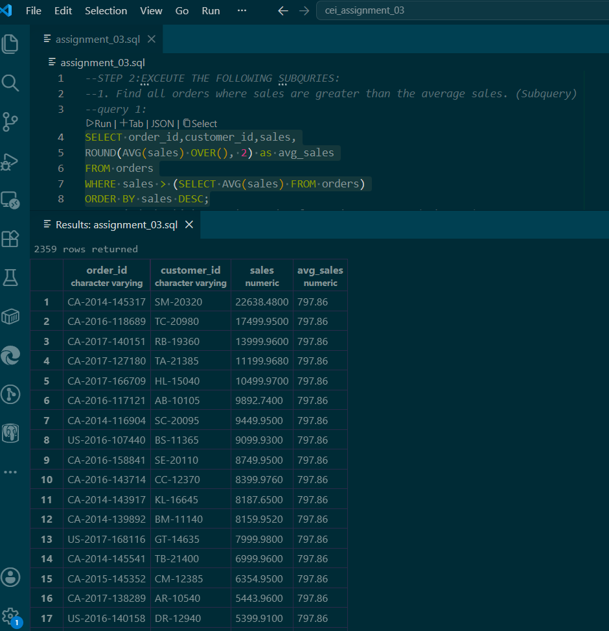
BOTTOM RESULT:
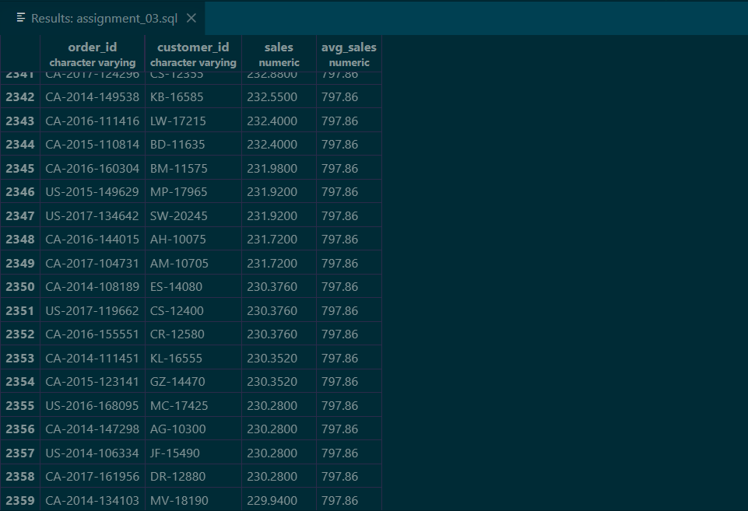
--TOTAL COUNT:
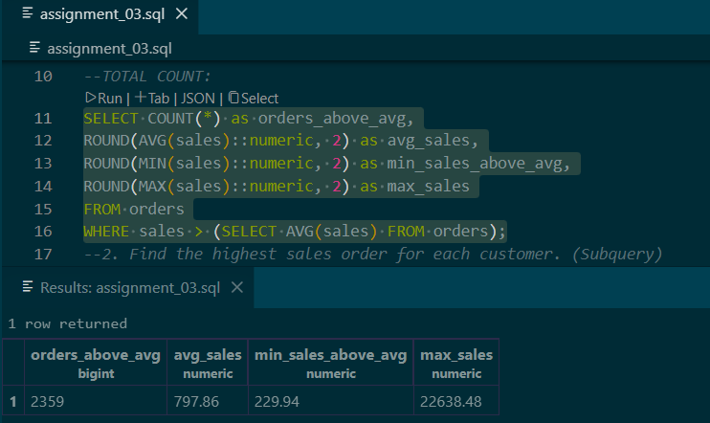

- Find the highest sales order for each customer. (Subquery)
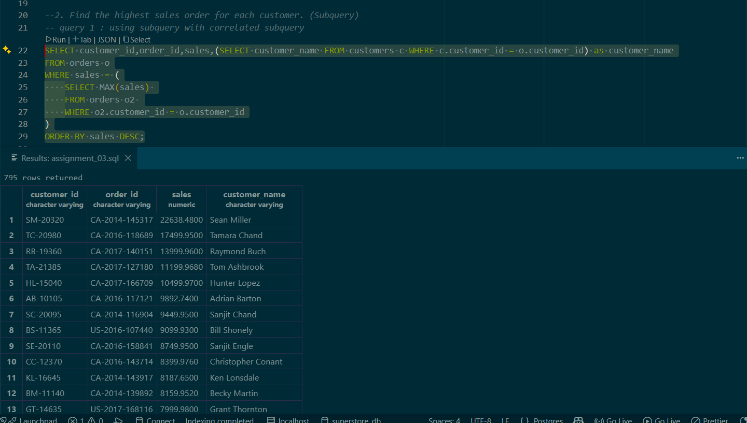

SHOWING TOP 10:
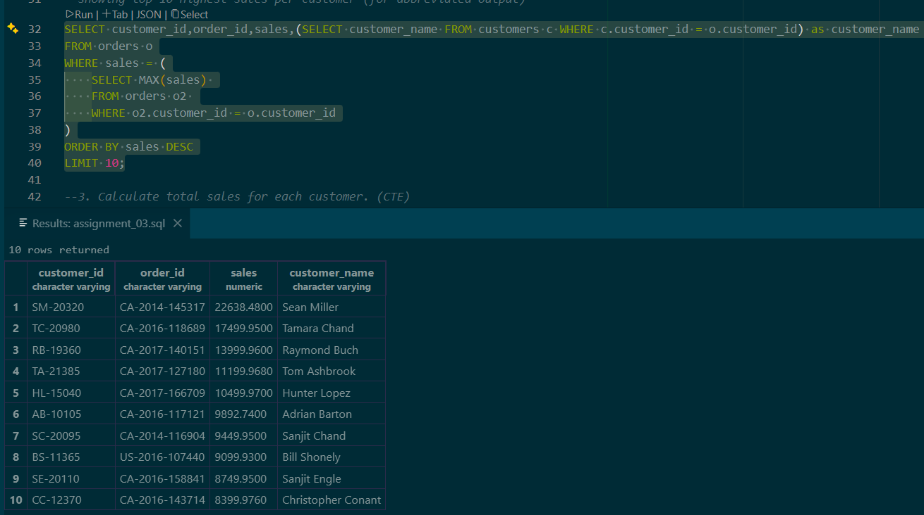

- Calculate total sales for each customer. (CTE)
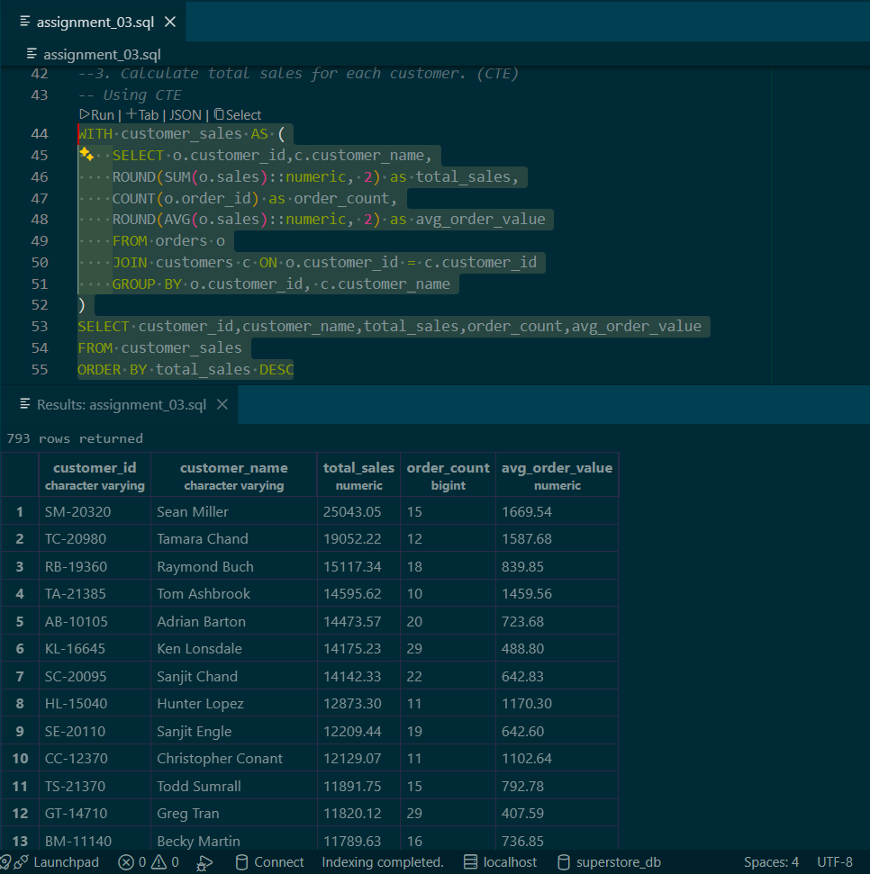
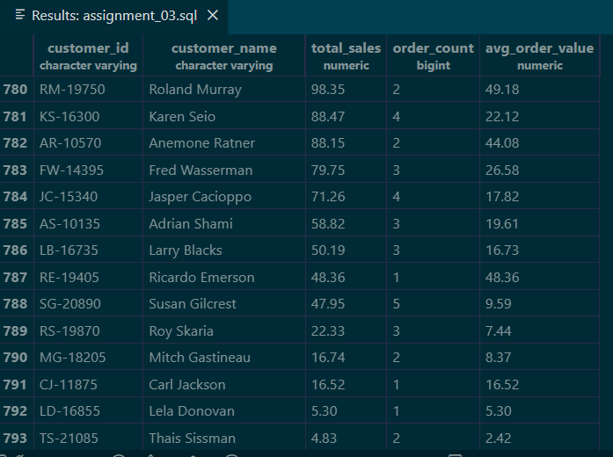

- Find customers whose total sales are above average. (CTE + Subquery)
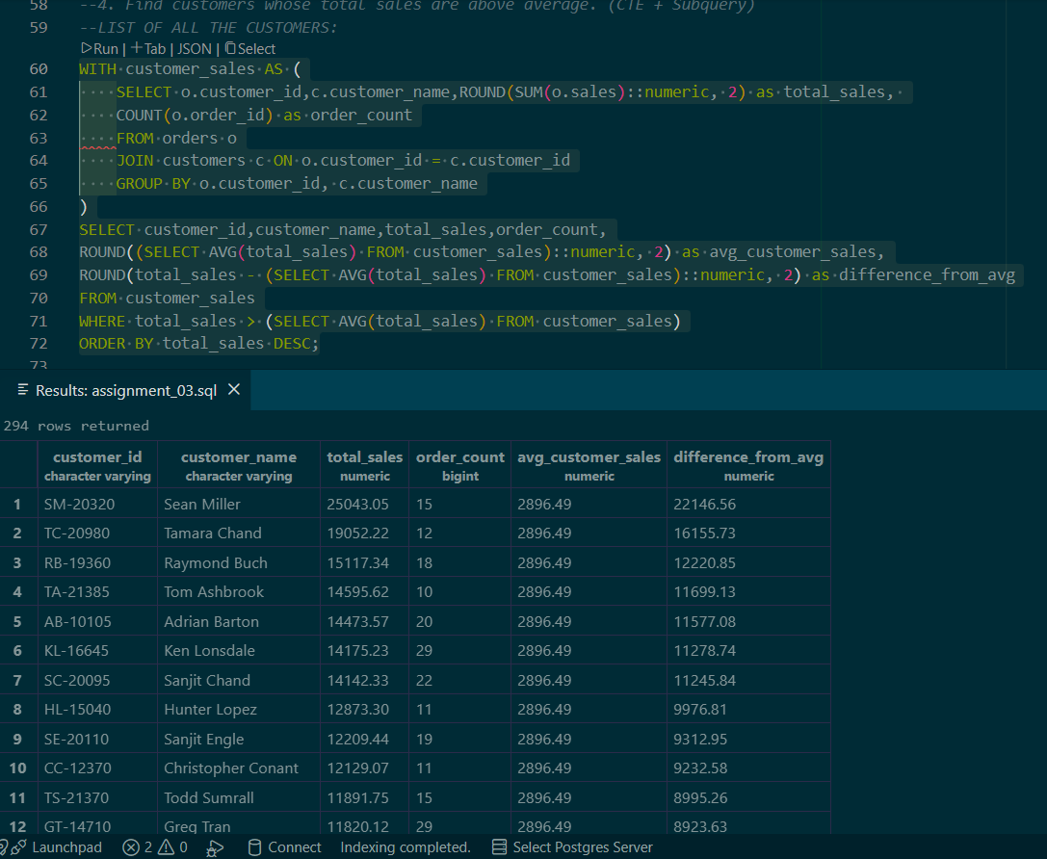
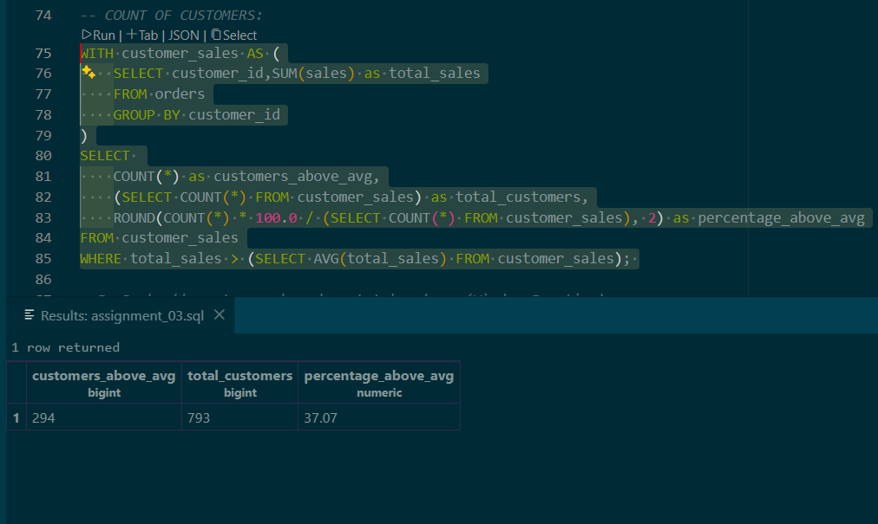

- Rank all customers based on total sales. (Window Function)
TOP:
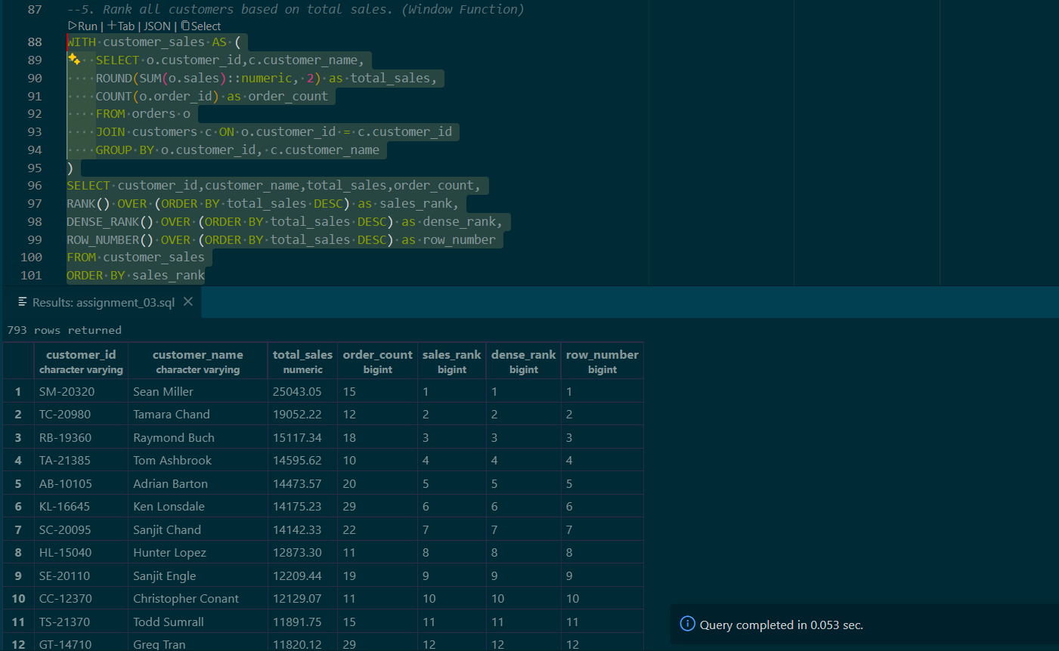

BOTTOM:
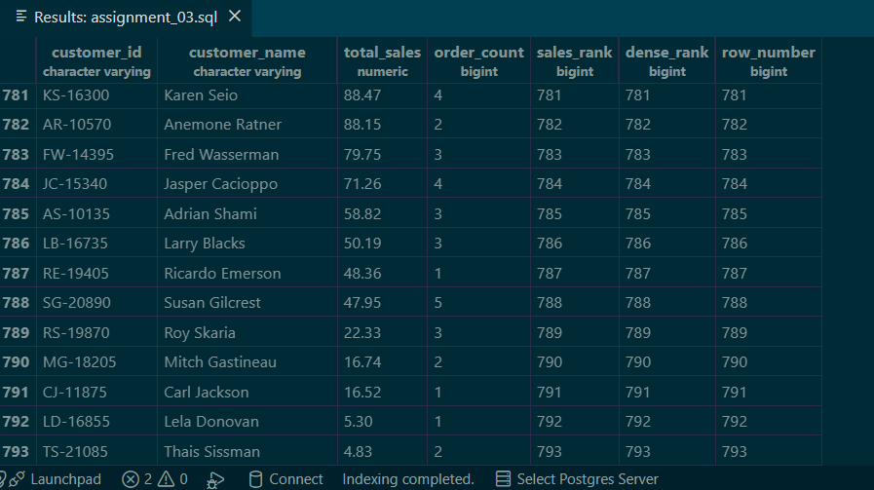

- Assign row numbers to each order within a customer. (Window Function + PARTITION BY)
TOP:
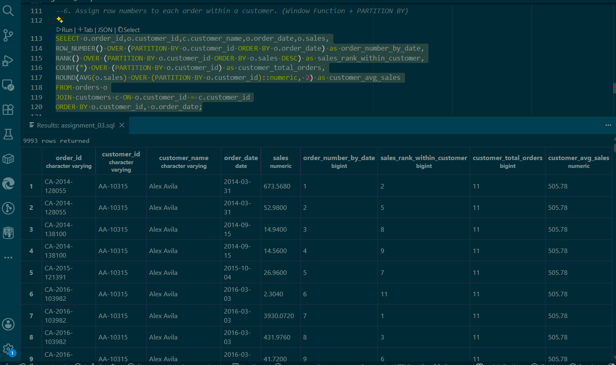
BOTTOM:
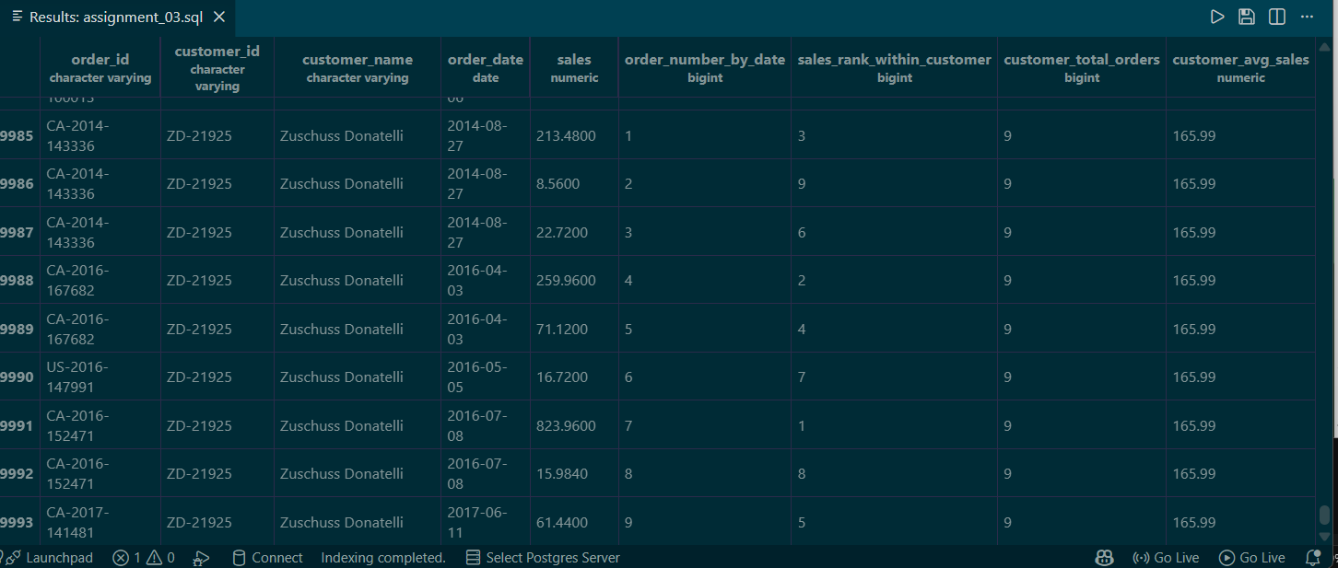

- Display top 3 customers based on total sales. (Window Function)
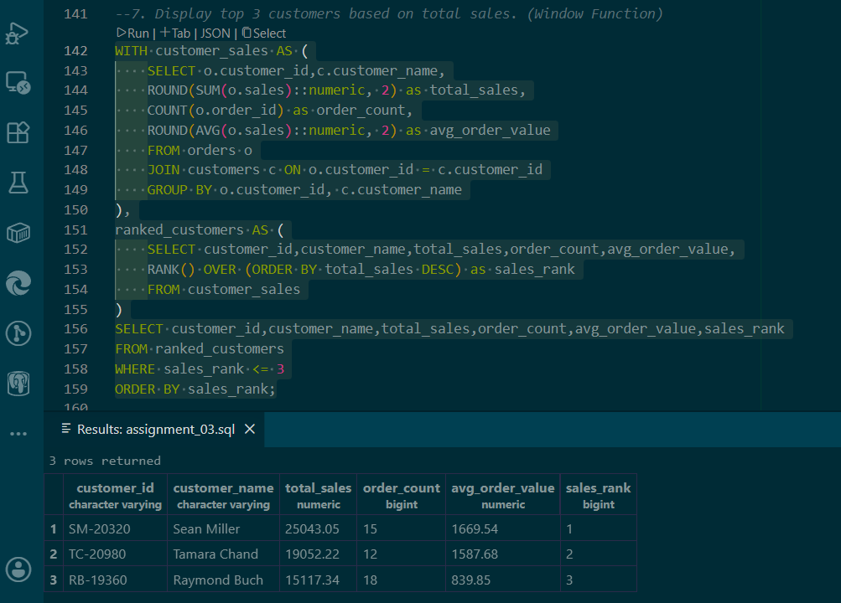

Step 3: Final Combined Query
Write one final query that shows:
- Customer Name
- Total Sales
- Rank
(Use JOIN + CTE + Window Function together)
QUERIES AND ITS RESULTS:
TOP:
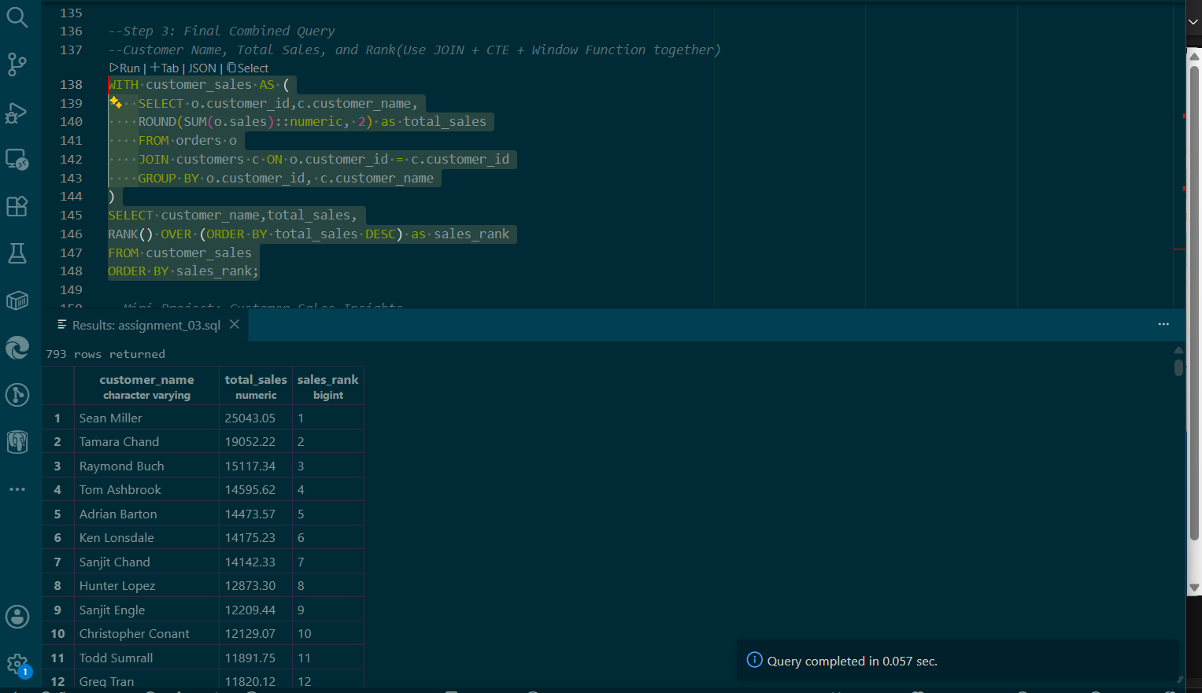
BOTTOM:
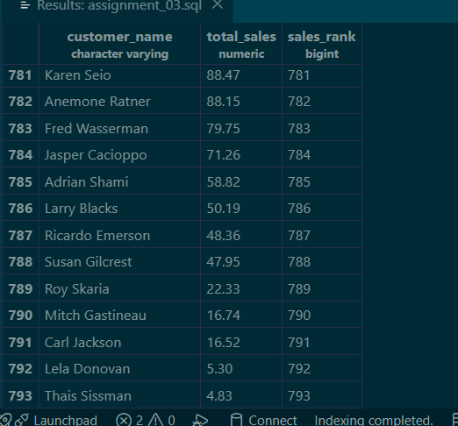

Mini Project: Customer Sales Insights
Answer the following using SQL:
- Who are the top 5 customers?
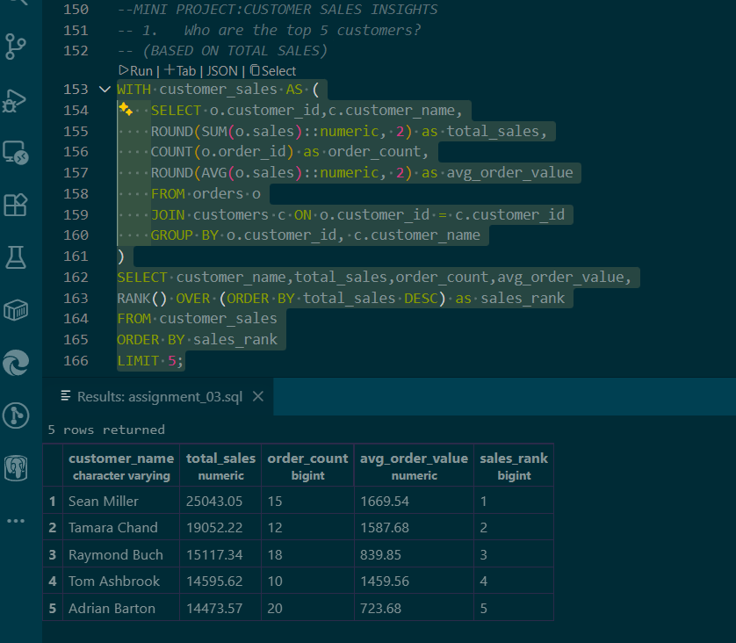

- Who are the bottom 5 customers?
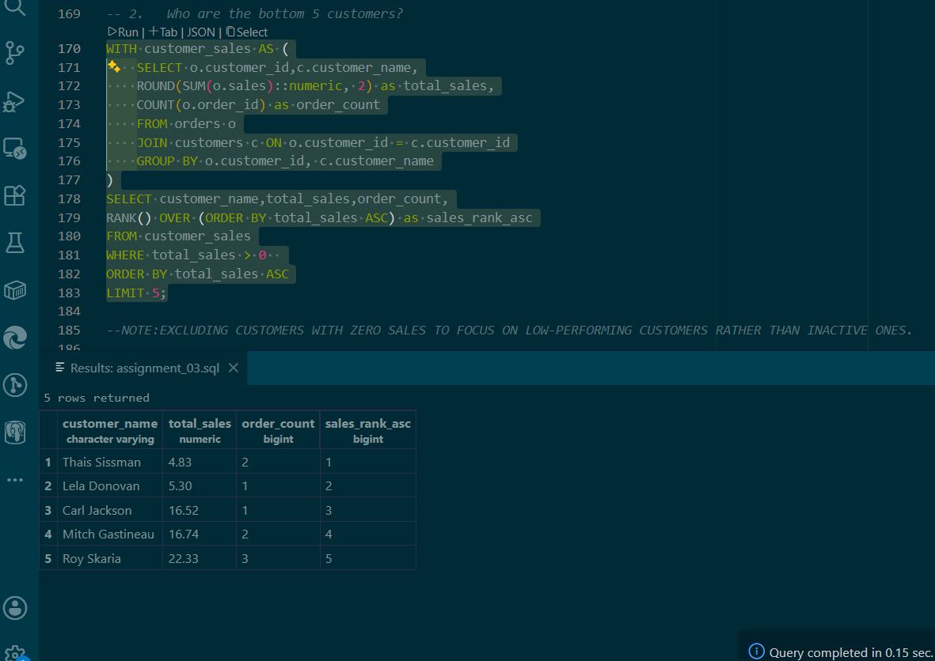

- Which customers made only one order?
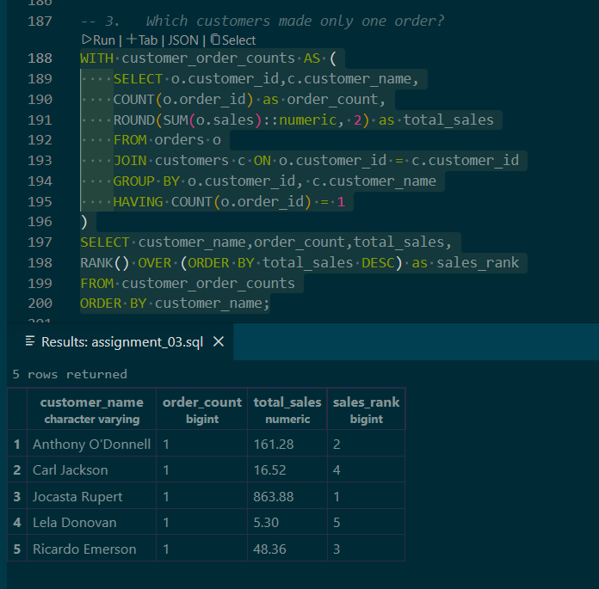

- Which customers have above-average sales?
TOP:
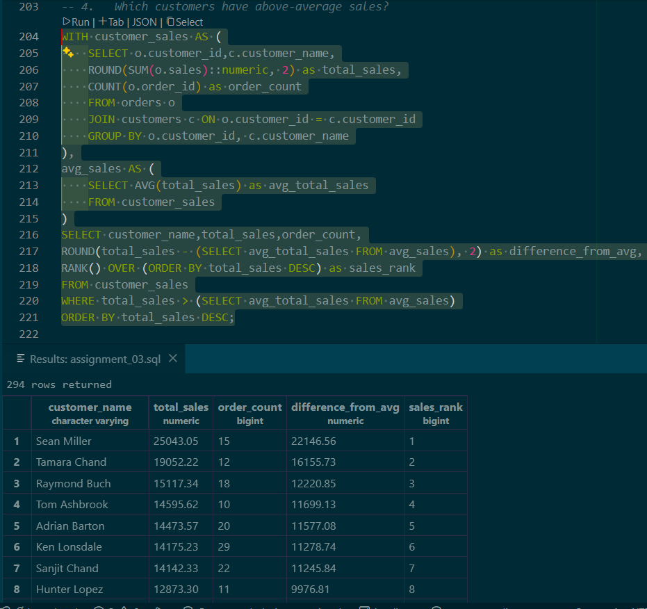

BOTTOM:
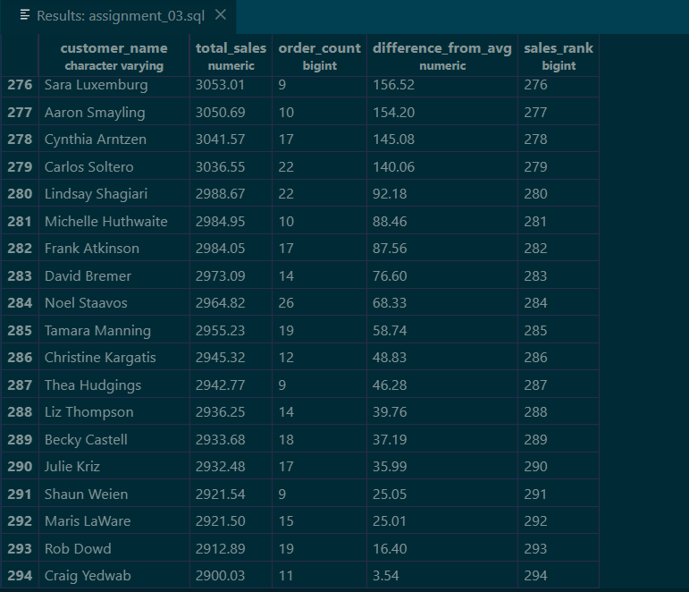
- What is the highest order value per customer?
TOP 10:

